

**Guitar Application**

Project By : Jibran Haider

Supervised by : Ma’am ZerAfshan

Arid No. : 15-Arid-48

Project : Guitar Tutor and lessons

Language : Swift

Tool : XCode

**Launch Screen :**

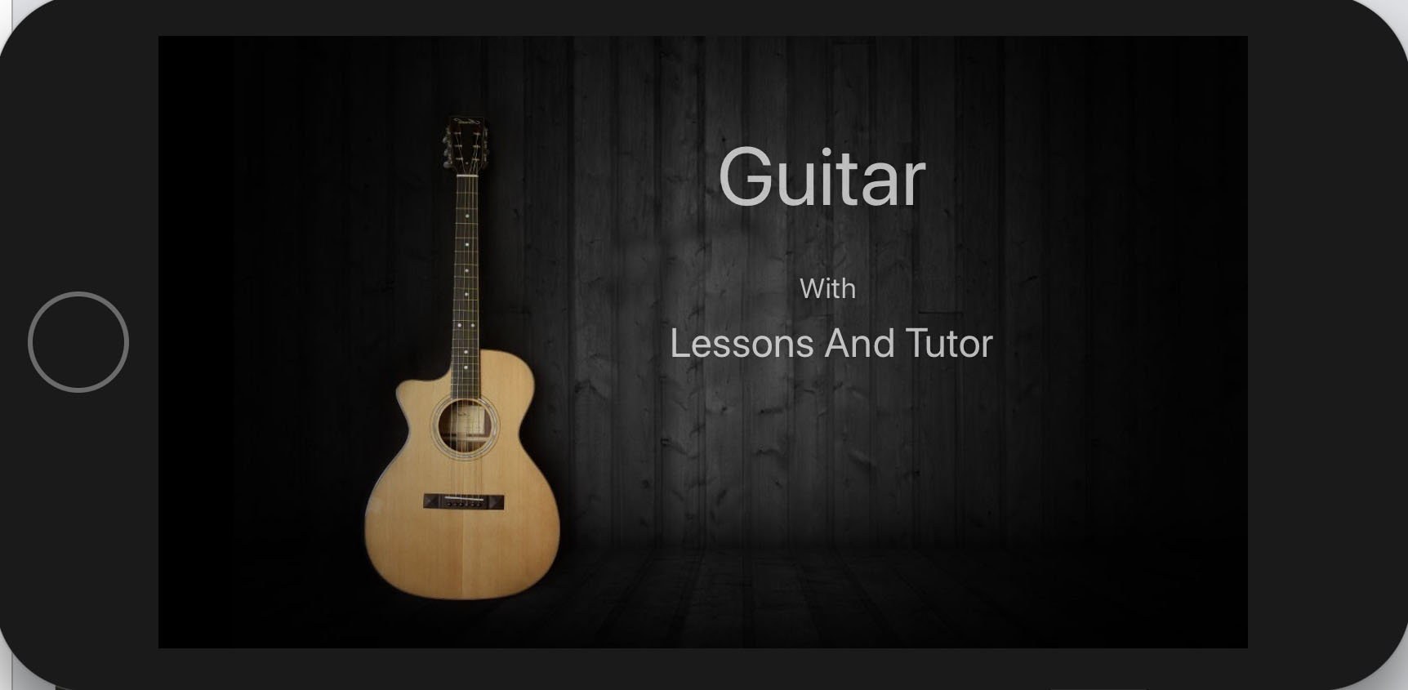

**Main Screen :**

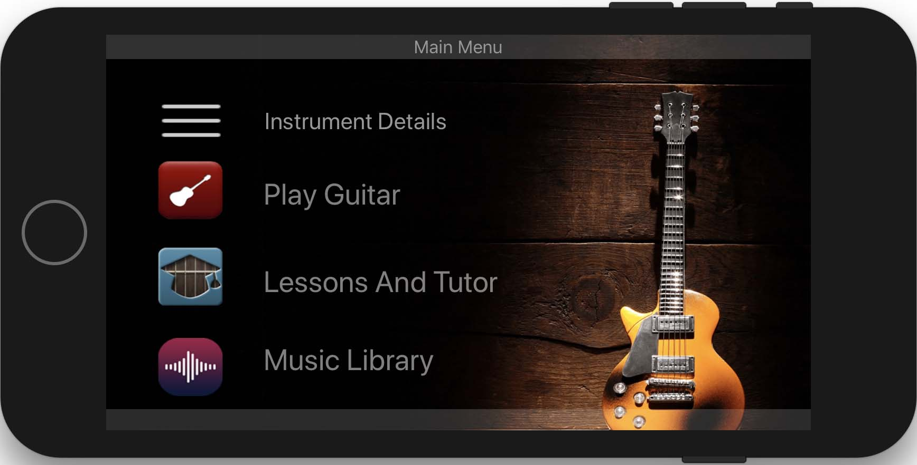

**Guitar Screen :**

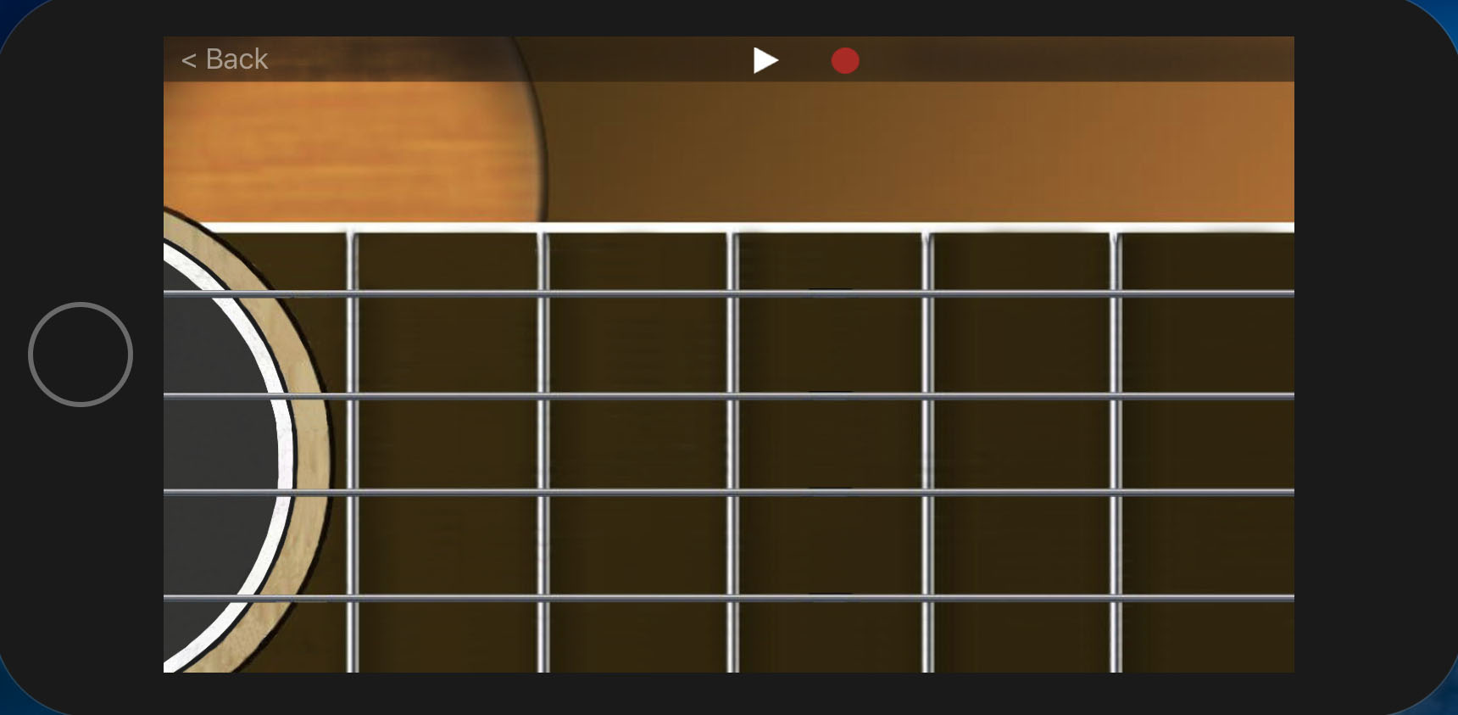

**Information Screen :**

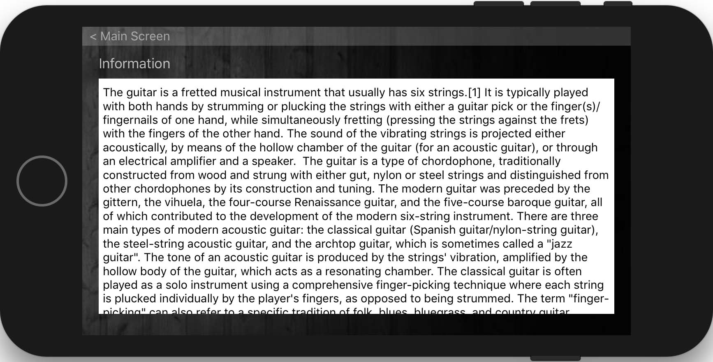

**Lesson Screen 1 :**

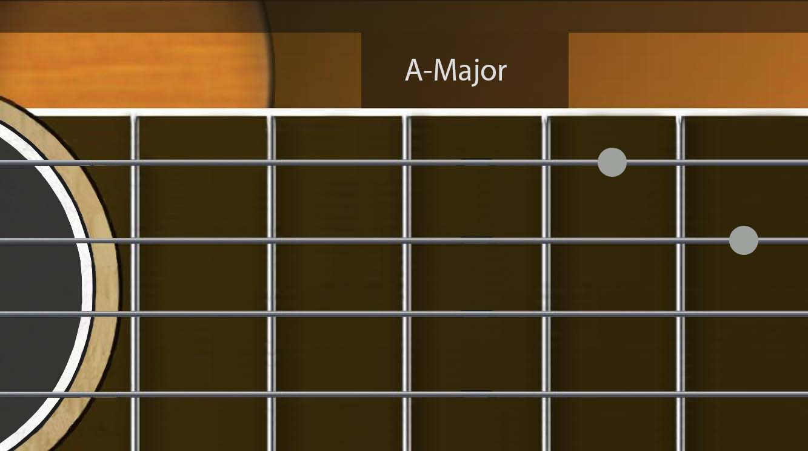

**Lesson Screen 2 :**

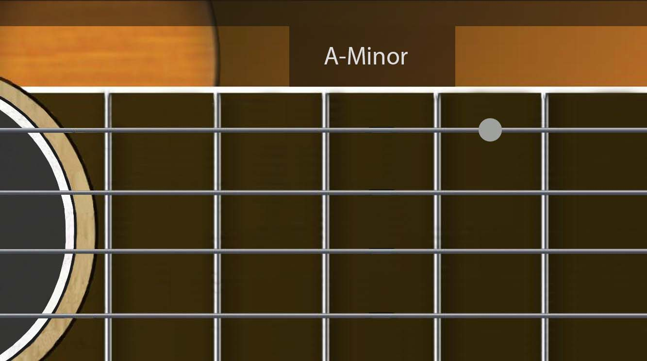

**Lesson Screen 3 :**

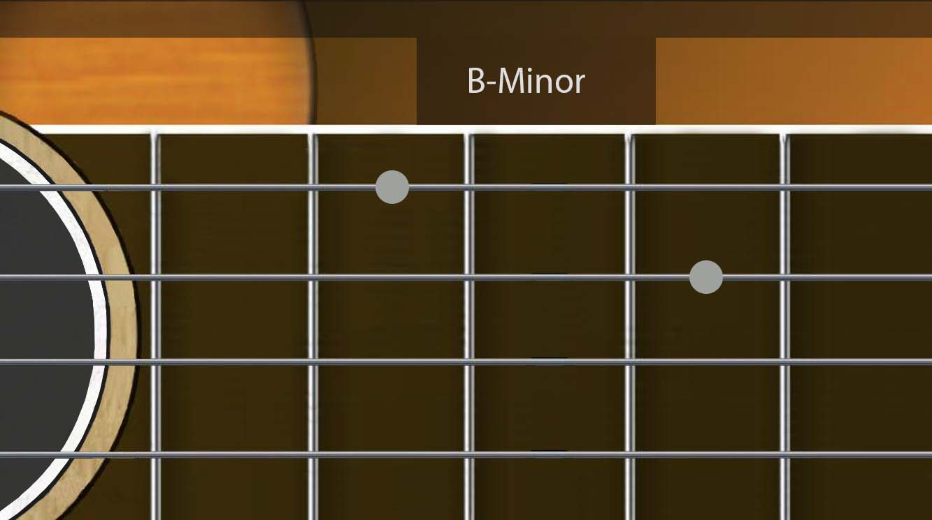

**Lesson Screen 4 :**

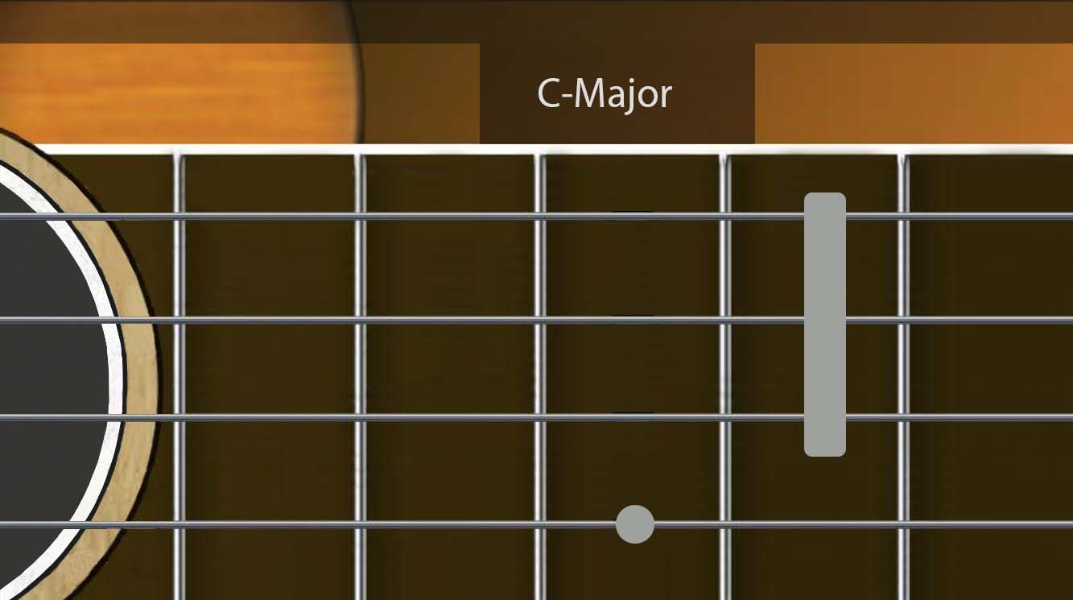

**Lesson Screen 5 :**

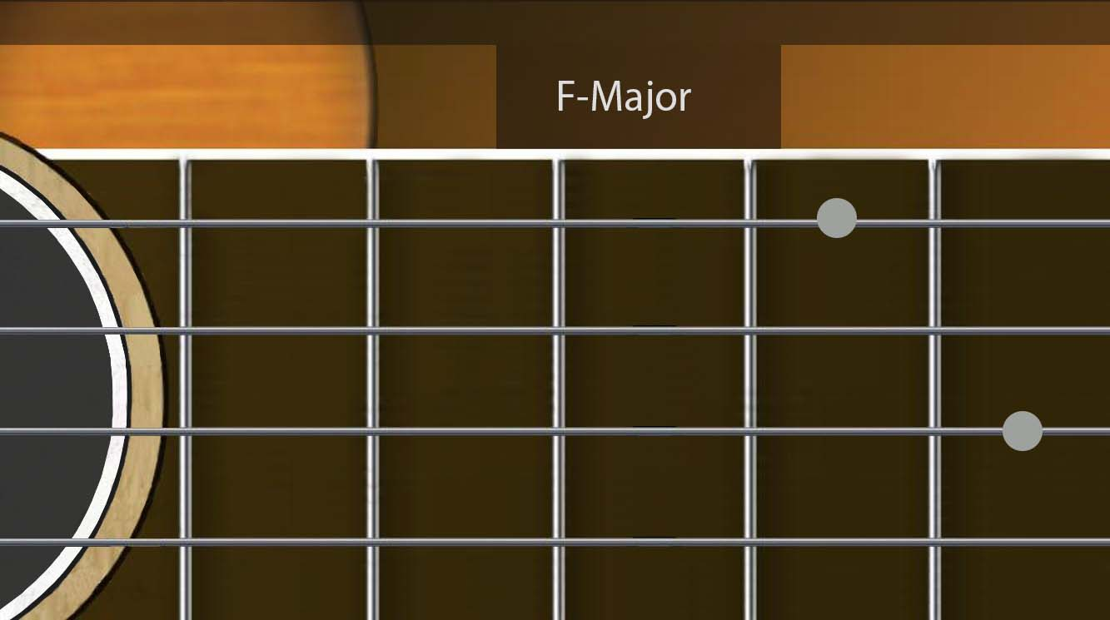

**Lesson Screen 6 :**

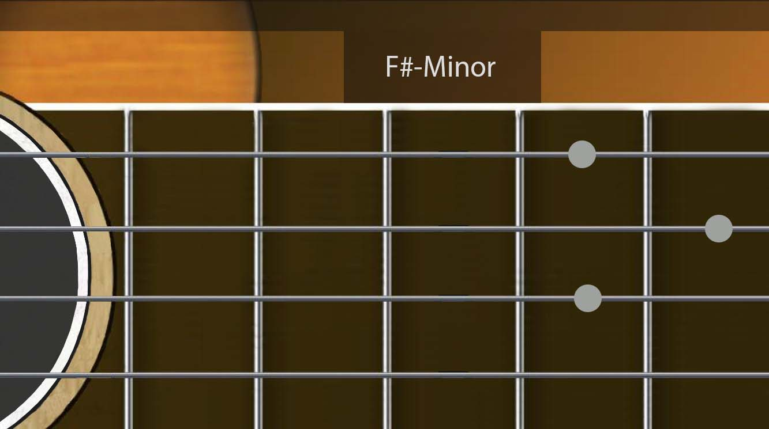

**Lesson Screen 7 :**

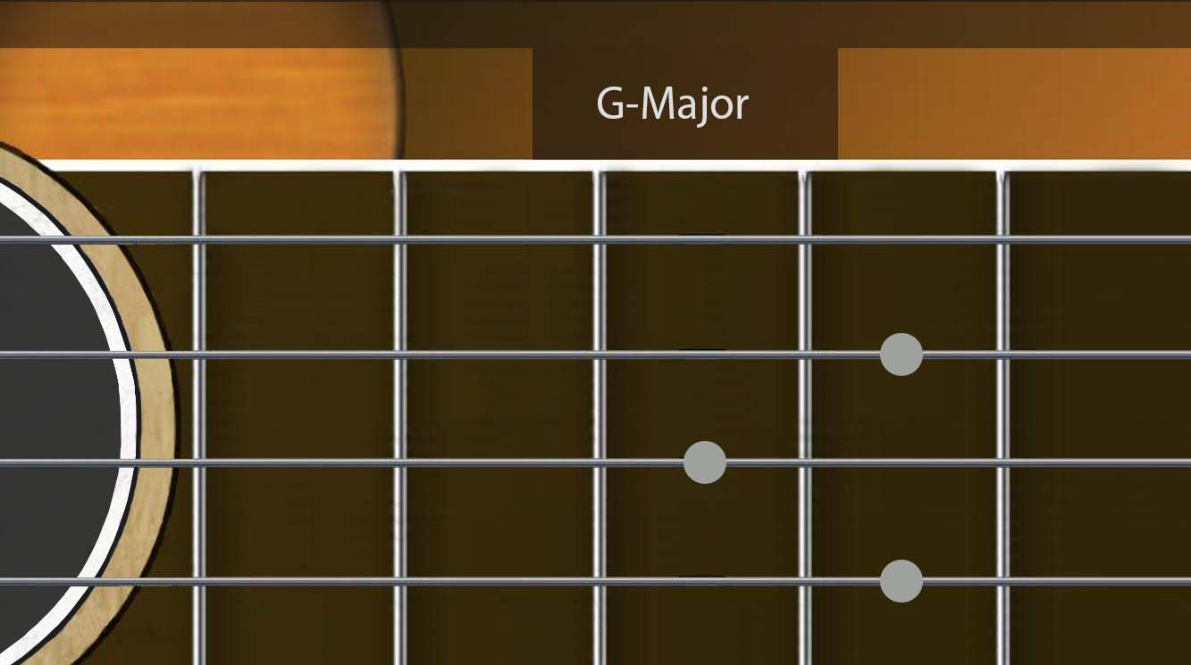

**Lesson Screen 8:**

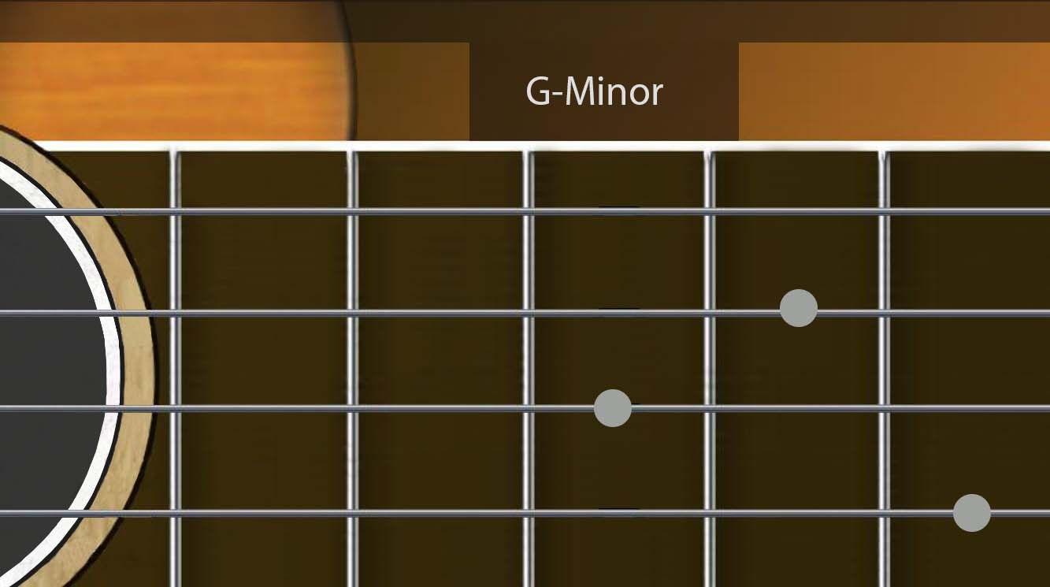

**Lesson Screen 9 :**

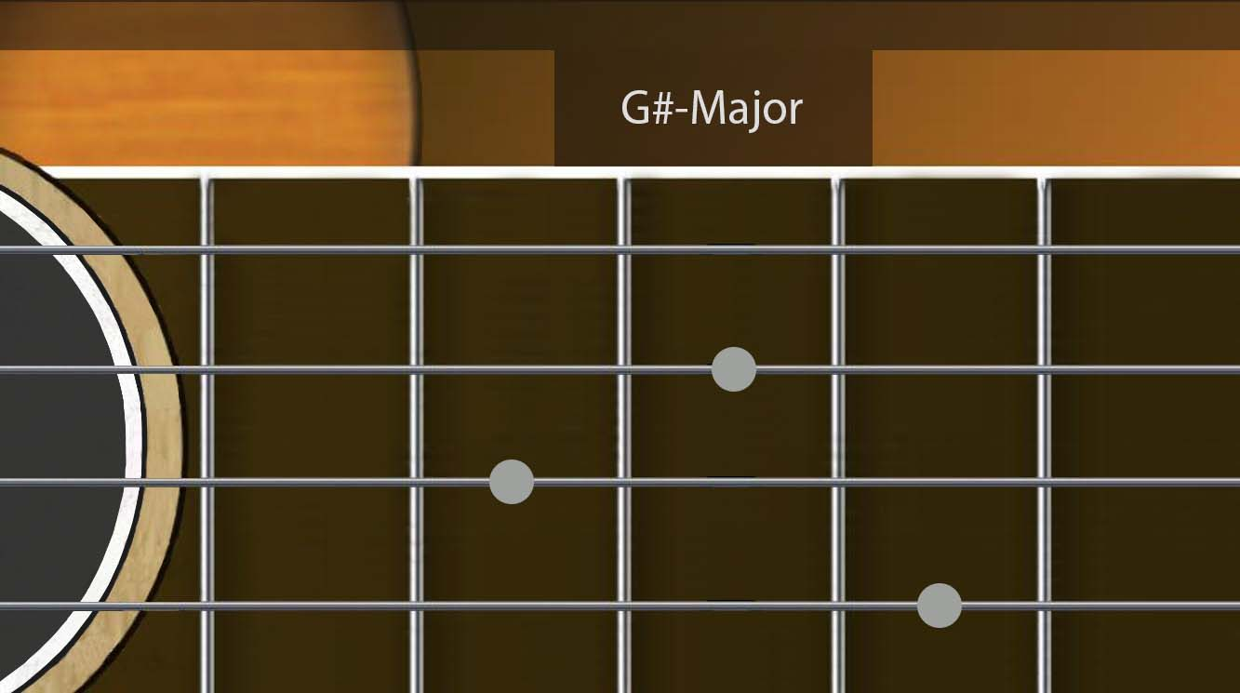

**Recorded Tracks :**

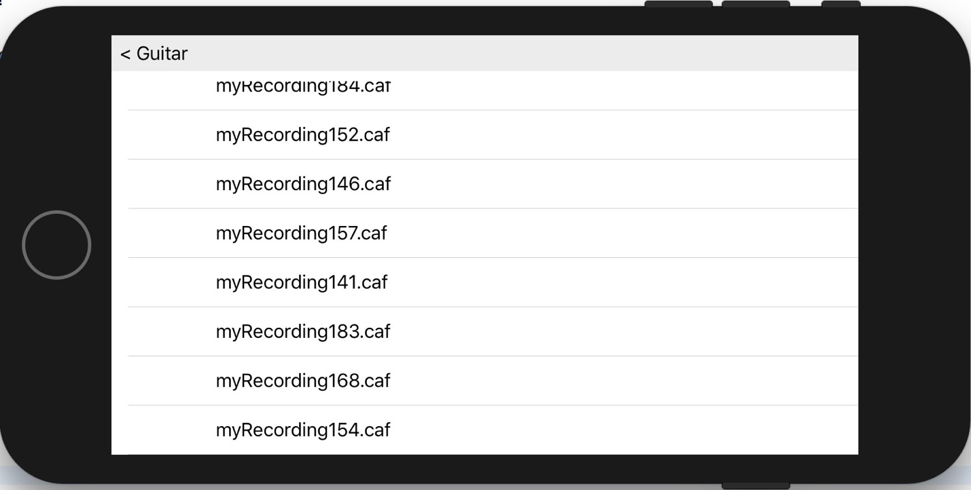

**Track Player :**

